**Automatic Funds Transfer Payment (AFT)**

**Authorization Form**

I do hereby authorize the El Jobean Water Association Inc. to withdraw funds monthly from the bank account shown below. The withdrawal will be on the due date as agreed upon of the 5th or 20th in the month due. This authorization is to remain in effect until El Jobean Water Association Inc. receives written notice from me terminating the authorization for Automatic Funds Transfer. In addition, I have the right to discontinue participation in the AFT program by notification to the El Jobean Water Association Inc. Office at least 7 business days prior to the due date of the payment. I will still be responsible for payment of my bill by the due date. I understand, however, that both the Financial Institution and the El Jobean Water Association Inc. reserve the right to terminate this payment plan or my participation.

A payment not honored by my bank will be handled in the same manner as a Returned Check and I will be charged a returned check fee.

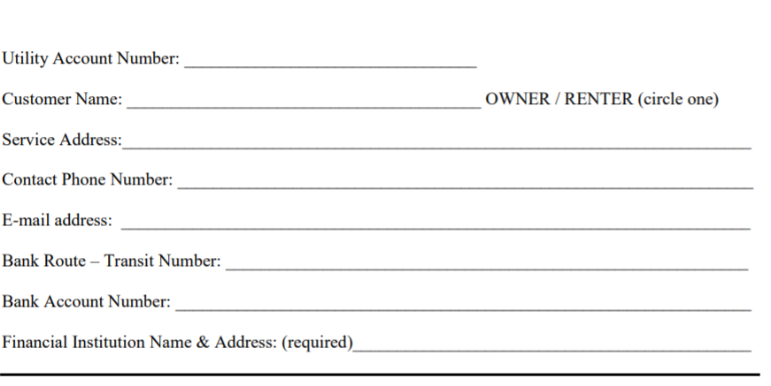Withdrawal date chosen: 5th or 20th (circle one)**____________________________________________________________________________________________________________________**

